**Day 3 - API Integration and Data Migration**

**Screen shots:**

* **API calls**
* **Data successfully displayed in frontend.**
* **Sanity CMS field**
* **Code for API integration and migration scripts**

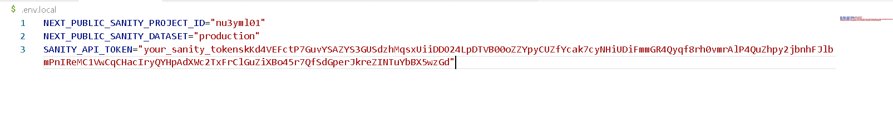

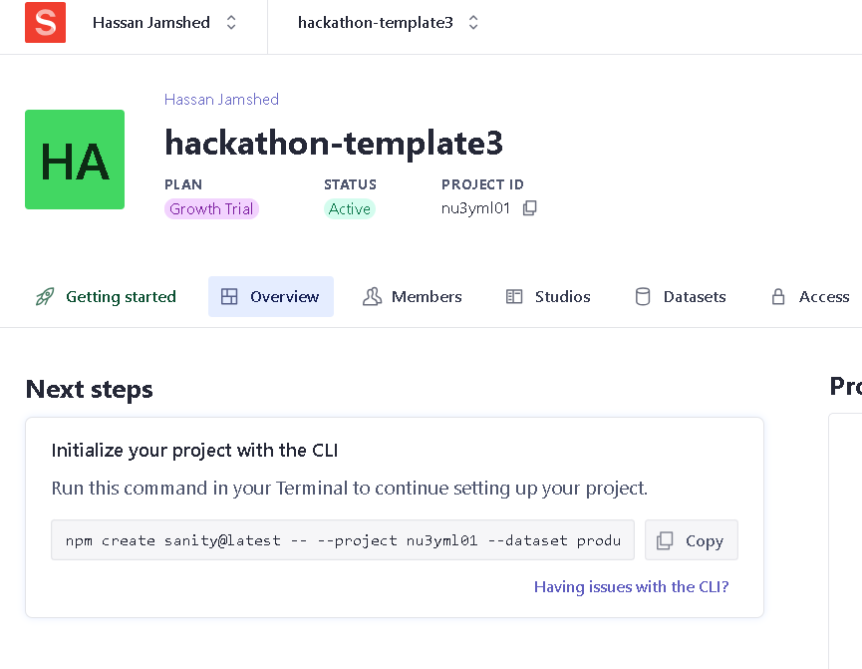

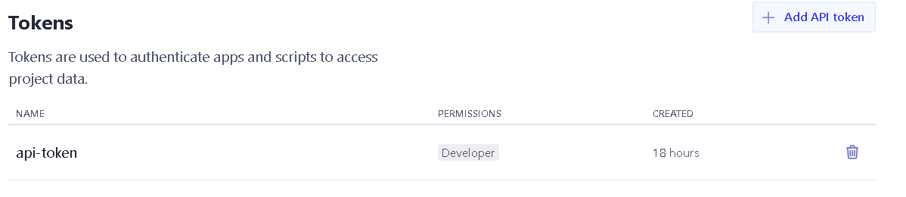

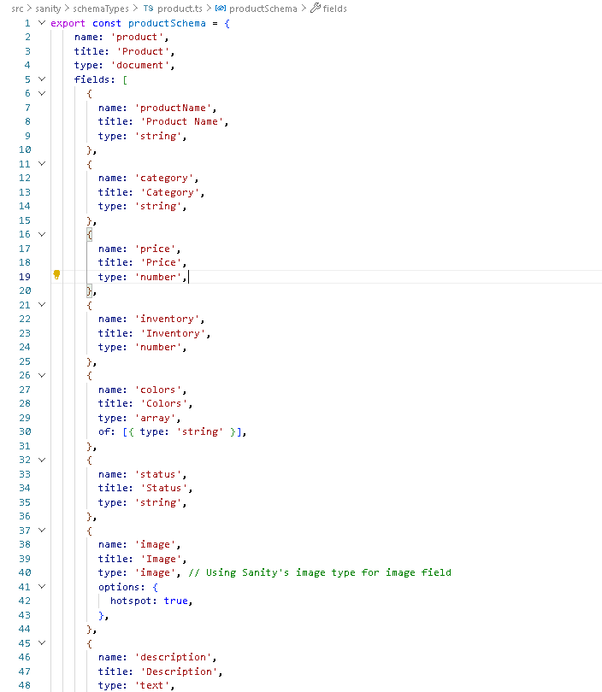

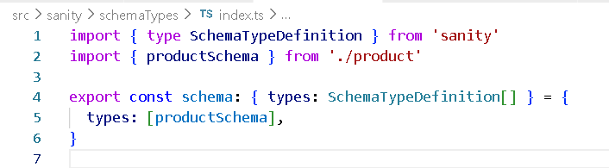

**Run following command:**

* npm install @sanity/client axios dotenv

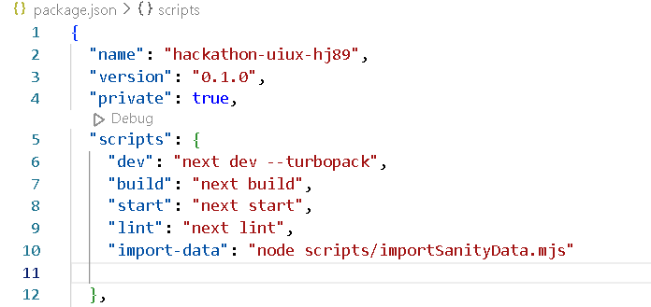

Now run the import script using:

* npm run import-data

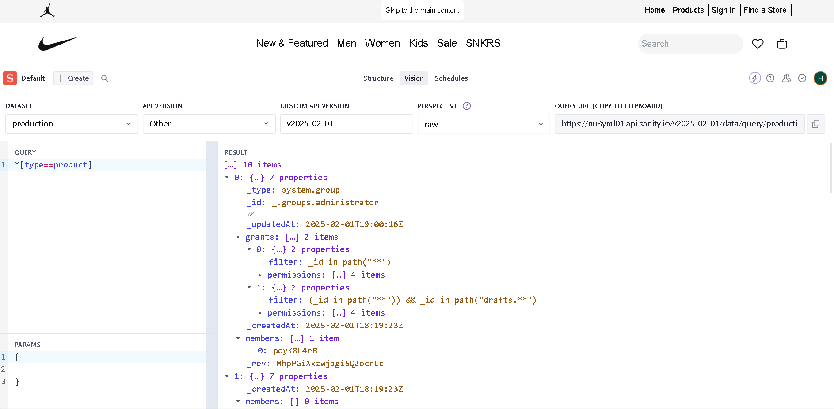

**Quotes:**

By following these steps I have learned how to configure environment variables for sanity integration, retrieve your sanity project ID and API token, create the custom product schema, and import data from an external API into your sanity content.